**Content Provider**

* A content provider manages access to a central repository of data.
* A content provider component supplies data from one application to others on request. Such requests are handled by the methods of the ContentResolver class.
* A content provider can use different ways to store its data and the data can be stored in a database, in files, or even over a network.
* **Content URI(Uniform Resource Identifier)** is the key concept of Content providers. To access the data from a content provider, URI is used as a query string.

**Structure of a Content URI: content : // authority / optionalPath / optionalID**

* **content:// –**Mandatory part of the URI as it represents that the given URI is a Content URI.
* **authority –**Signifies the name of the content provider like contacts, browser, etc. This part must be unique for every content provider.
* **optionalPath –**Specifies the type of data provided by the content provider. It is essential as this part helps content providers to support different types of data that are not related to each other like audio and video files.
* **optionalID –**It is a numeric value that is used when there is a need to access a particular record.

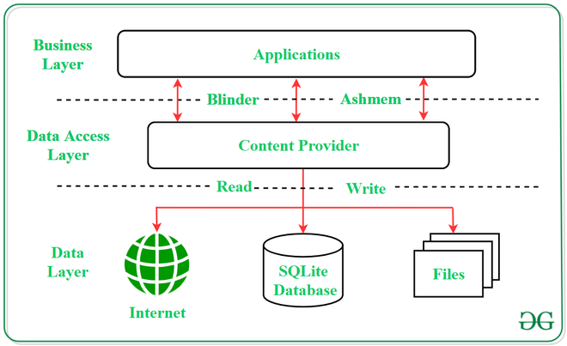

* UI components of android applications like [Activity](https://www.geeksforgeeks.org/activity-lifecycle-in-android-with-demo-app/) and [Fragments](https://www.geeksforgeeks.org/introduction-fragments-android/) use an object **CursorLoader**to send query requests to **ContentResolver.**
* The ContentResolver object sends requests (like create, read, update, and delete) to the **ContentProvider**as a client.
* After receiving a request, ContentProvider process it and returns the desired result.

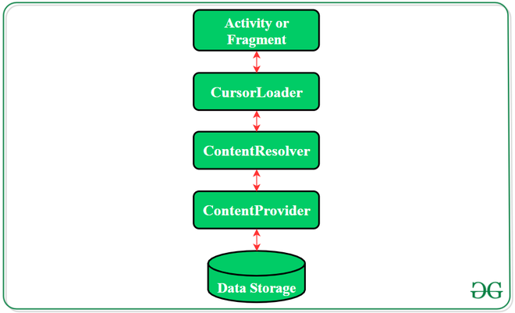

[query (Uri, projection, selection, selectionArgs, sortOrder)](https://developer.android.com/reference/android/content/ContentResolver#query(android.net.Uri,%20java.lang.String[],%20android.os.Bundle,%20android.os.CancellationSignal))

|  |  |  |
| --- | --- | --- |
| **query() argument** | **SELECT keyword/parameter** | **Notes** |
| Uri | FROM table_name | Uri maps to the table in the provider named *table_name*. |
| projection | col, col, col, ... | Projection is an array of columns that should be included for each row retrieved. |
| selection | WHERE col = value | Selection specifies the criteria for selecting rows. |
| selectionArgs | (Selection arguments replace placeholders in the selection clause.) |  |
| sortOrder | ORDER BY col, col, ... | sortOrder specifies the order in which rows appear in the returned [Cursor](https://developer.android.com/reference/android/database/Cursor). |

| Method | Description |
| --- | --- |
| query() | A method that accepts arguments and fetches the data from the  desired table. Data is retired as a cursor object. |
| insert() | To insert a new row in the database of the content provider.  It returns the content URI of the inserted row. |
| update() | This method is used to update the fields of an existing row.  It returns the number of rows updated. |
| delete() | This method is used to delete the existing rows.  It returns the number of rows deleted. |
| getType() | This method returns the Multipurpose Internet Mail Extension(MIME)  type of data to the given Content URI. |
| onCreate() | As the content provider is created, the android system calls  this method immediately to initialise the provider. |